Table of Contents

Table of Figure 2

1. Introduction 3

**Introduction to Project** 3

**Background of the Project** 3

**Problem statement** 3

**Description of the project** 3

Features of the project: 3

**Overview of the project** 3

2. Scope of the Project 4

**Scope** 4

**Limitation** 4

**Aims** 4

**Objectives:** 4

**Overview of the Scope:** 4

3. Development Methodology. 5

**Description of methodology:** 5

Design Pattern: 6

**Architecture** 7

4. Project Planning: 8

**WBS** 8

**Milestones** 9

**Gantt Chart** 10

5. Risk Management 13

6. Configuration Management: 15

7. Conclusion: 16

8. References 17

# Table of Figure

Figure 1 waterfall methodology 5

Figure 2Model View Controller (MVC) 6

Figure 3Client/Server architecture. 7

Figure 4WBS for project 8

Figure 5Gantt chart schedule. 10

Figure 6Gantt Chart 11

Figure 7configuration management 14

|  |
| --- |
| **Project Proposal on Real Estate Website.** |

# Chapter 1: Introduction

**Introduction to Project:** Project will focus on Property buying/selling and rental. I am trying to solve the problem, buyer and seller have to face while buying, Selling and renting property through this project. Real estate website is a website where buyers and sellers can meet, advertise their property for rent and sell and lookup for perfect property. This website makes buying and selling property easy.

**Background of the Project:** Real estate website is based on agents. Buyer had to go through agent to buy and sell the property, which costs extra % of budget to both buyer and seller. Property owners doesn't get real value for their property and buyer end up paying high amount due to agents.

**Problem statement:** I am trying to remove agent from property market. Agents are not easy to trust and if they are trust worthy they must be paid high amount of money. Buying and selling property is difficult and costly due to agent fees. I am trying to create a centralized online market for property where buyer and seller can meet each other.

**Description of the project:** This project will focus on property buying/selling and rental without the involvement of agents. Seller can directly upload their property details and buyer can view and request if interested. Buyer and seller can then bargain on property through the same website without involvement of the agents.

### Features of the project:

* Seller can upload the details of property and advertise their property.
* Buyer can view the product, be interested in property.
* Signup/Login Form (Membership)
* online conversation through messaging.
* Rating and reviewing.
* Features of online booking of product.

**Overview of the project:** This website will make easy for buying and selling property. Buyer and seller can view each other's details online. Buyer and seller can buy/sell and rent property without the involvement of agent and without extra fees. My project is trying to build a relationship between buyer and seller So, that they can buy/sell property without any doubt. Review and rating will help buyer to lookup seller's portfolio and it will also help honest seller to improve their sale through rate and review.

# Chapter 2: Scope of the Project

**Scope:** Scope of this Project Focusing on certain goal and People listed below:

* To Create an online market for Property, Buy/Sell and Rental
* Buyer of Property.
* Seller of Property.
* Students/Teachers and People living in Kathmandu valley searching for room/flat.
* Owner of house who want to give their room/flat on rent.

**Limitation:** Limitation of this projects are**:**

* + - Developed only as a website.
    - Developed to Focus on Specific area only.

**Aims:** Main aim of this projects is to:

* To create an online market for Real Estate Property.
* Ease for Rental service in Kathmandu Valley.

## **Objectives:**

* + - Login and signup form will be created for member login.
    - Buyer and seller will have discussion though online messaging.
    - PHP/JavaScript and MYSQL will be used throughout the development of project.
    - Rating and review will be added for betterment of property details**.**

## **Overview of the Scope:**

This project will focus mostly to people living in Kathmandu Valley, who are in search of Renting Room/Flat and the owner of the property. It will be developed using PHP and MYSQL. It will help to create a centralized market for Property Rental/buying and selling. Buyer and seller will meet virtually through this website and have discussion on Property. This project will solve the problem related to difficulties of searching room, proper room finding and property which will be suitable. This website will create a login and registration for both buyer and seller where they can store their details, can upload property for sale and search for suitable property. Utilizing this website buyer/seller doesn't have to run from agent to agent for buying/selling.

# Chapter 3: Development Methodology.

## **Description of methodology:**

Waterfall Development Methodology: The [waterfall method](https://en.wikipedia.org/wiki/Waterfall_model) is considered the traditional software development method. It’s a rigid linear model that consists of sequential phases (requirements, design, implementation, verification, maintenance) in which distinct goals are accomplished. Each phase must be complete before the next phase starts. (Synopsys, 2019)

**Reasons for choosing waterfall methodologies**: The nature of this strategy makes it straightforward and manageable. I have a Project with clear targets and stable requirements in which waterfall method can be best use. Waterfall methodologies is a simple, straight-forward approach. It will be easy to develop since every phase has Start and End.

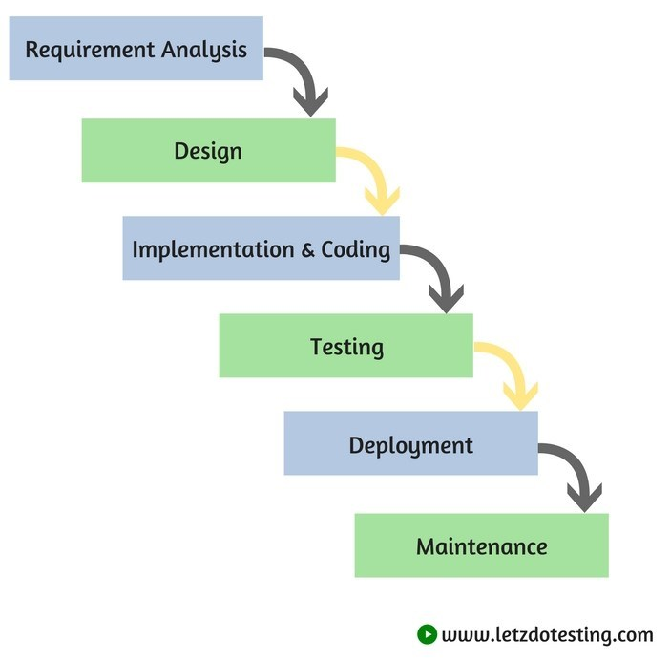

Figure 1 waterfall methodology

# Design Pattern:

I will choose **MVC Design Pattern** for this project

MVC design pattern defines that a software consists of a data model, presentation information, and control information. The pattern requires that each of these be separated into different objects.

**Model (M)**: The Classes used to store and manipulate State.

**View(V):** The user interface to render the model of system to user.

**Controller (C):** Brain of the website. It decides where user inputs, how to process output as per user request and which output value should be used.

(GeeksforGeeks, 2019)

**Reason for choosing MVC design pattern:** Model view controller provides the idea of separating the logic from the display properly. MVC helps to calculate the logical process of project which will make project secession easier and faster. MVC framework makes easier to reuse code without rewriting it. It is said to be a good way to develop clean, reliable, powerful and fast code in less time and less effort. (Htmlgoodies.com, 2019)

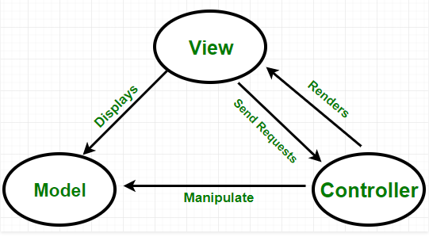

Figure 2Model View Controller (MVC)

**Architecture**: **Client/Server** architecture will be suitable for my project.

**Client/Server architecture:** In client/server architecture, computer processed in a network is either client or server. This architecture significantly decreases network traffic by providing query response rather than full file search.

**Reason to choose Client/Server architecture:** Client server will be better as we can set limitation for what user can access and also to filter client as per nature of client. Cisco network academy suggest using centralized server to connect more than 10 computers, which enhance its reliability as a centralized server. (Webopedia.com, 2019) (|, 2019)

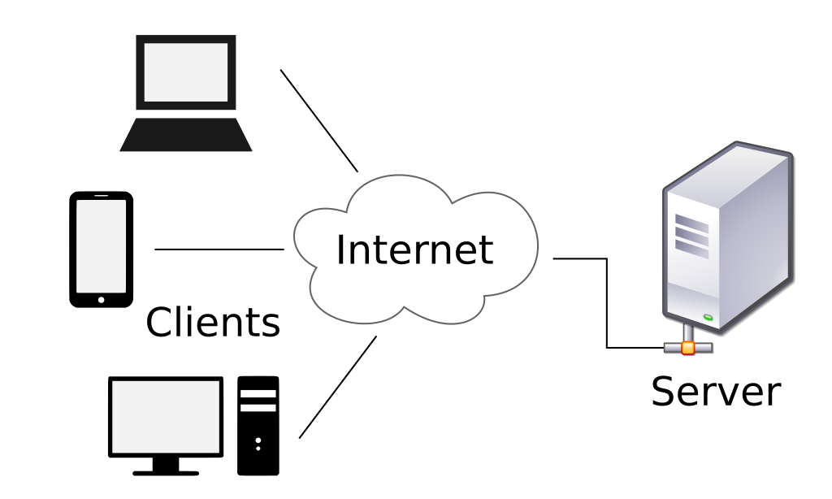

Figure 3Client/Server architecture.

# Chapter 4: Project Planning:

Project planning phase is the starting point of the project. A good project plan leads proper management of project development. we don't have to worry about time as if we plan project accordingly to its time. It sets out process expected to be followed so it avoids headache later. I will try to create a project plan by using Work break-down structure. It will help to create a plan for every phase involved in project development**.**

**WBS**: Work break-down structure is design to make complex project more manageable, by breaking it into chunks which can be supervised and estimated. Development process will be much easier with the help of WBS. I will break down my project into several part to supervise and estimate my work. (Bright Hub PM, 2019) (Tensix.com, 2019)

And the Work break-down for my project is shown below:

Figure 4WBS for project

**Milestones**: Milestones is a major trail maker in my schedule for my project. It will help us to locate exactly where are we in project development. Completing project will be easy if we estimate a starting time and its deadline for certain task of project. Project management milestones is a point in time used to measure progress of project. Milestones of my Project is listed below:

|  |  |  |  |
| --- | --- | --- | --- |
| **S.no** | **Milestone** | **Start date** | **Finish date** |
| **1** 1.1 1.2 1.3 1.4 1.5 1.6 1.7 1.8 | **Project Proposal** Introduction of Project. Scope of Project Development methodology. Project Planning Risk Management Configuration management. Conclusion. References and bibliography | 25th March. 25th March. 27th March. 30th March. 3rd April. 5th April. 7th April. 8th April. 9th April. | 9th April. 26th March. 29th March. 2nd April. 4th April. 6th April. 7th April. 8th April. 9th April |
| 2 2.1 2.2 2.3 2.4 | **Analysis**  Feasibility study Requirement analysis Use Case Architecture | 10th April. 10th April. 14th April. 24th April.  28th April | 7th May. 13th April. 23rd April. 27th April. 7th May |
| 3  3.1  3,2  3.3  3.3 | **Design**  Structural Model Behavior Model Database Design UI Design | 8th May. 8th May. 15th May. 24th May. 29th May | 1st June. 14th May. 23rd May. 28th May. 1st June. |
| 4 4.1 | **Implementation**  Coding | 2nd June. 2nd June | 21st June. 21st June. |
| 5  5.1  5.2 | **Testing**  Unit testing.  integration testing. | 22nd June. 22nd June. 26th June. | 29th June. 25th June. 29th June. |
| 6 6.1 6.2 6.3 | **Final Documentation** Review of Product User Manual Final Product | 30th June. 30th June. 4th July. 8th July. | 10th July. 3rd July. 7th July. 10th July |

I will start my Project from 25th march and end in 10th of July. I will give 16 days to Proposal where I will introduce the project along with its scope in 5 days, I will give 4 days to development methodology, because choosing development methodology can be confusing. Project plan and Risk management will be done taking 2 days each i.e. 4 days. Configuration management, conclusion and referencing and citation will be done on 1 day each. I will give analysis 28 days where Requirement analysis and architecture will take time. So, I will give much time to it i.e. 10 days each, other two task i.e. feasibility study and use case will consume 4 days each. Easiest part for me in design will be Use case so I decided to give less time then other tasks. Implementing the code will take 20 days of total time, because error will may be difficult to fix in coding. I will give 4 days each for unit testing and integration testing, because testing is equally important. Final documentation will be done in maximum of 11 days.

**Gantt Chart**: Gantt chart can be used for tracking project schedule. It is a way of presenting activities/tasks against time. Gantt chart in development process helps the developer to visually plan and track project. I have a lot of moving part in my project which are time sensitive. So, everything is planned properly and scheduled with the help of Gantt chart. Gantt chart for my project is shown below: (Gantt.com, 2019) (Smartdraw.com, 2019)

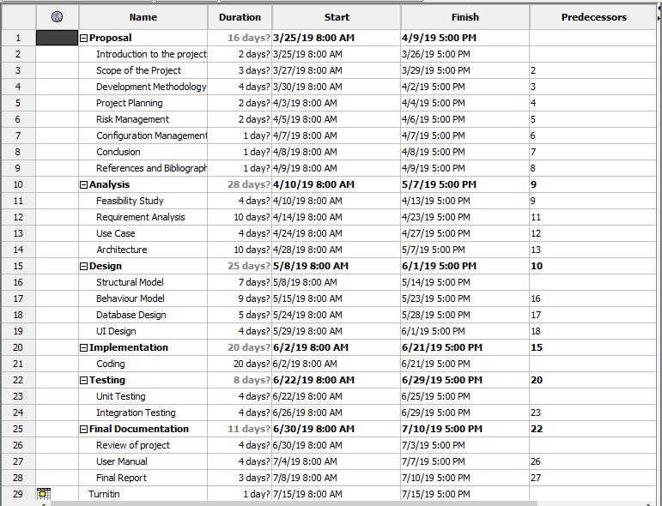

Figure 5Gantt chart schedule.

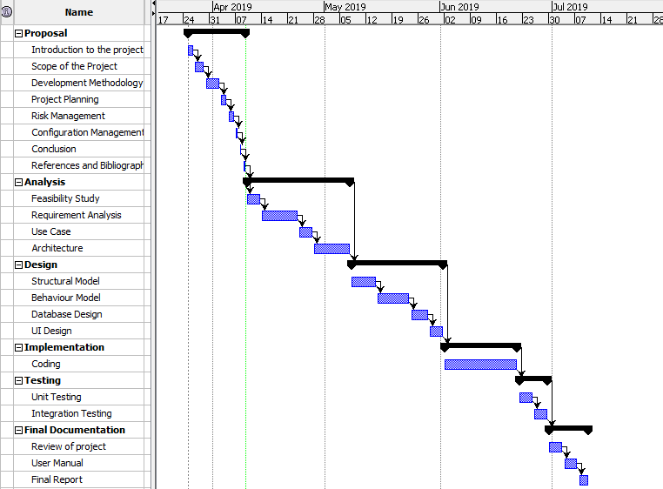

Figure 6Gantt Chart

# Chapter 5: Risk Management

Anything that can negatively affect the project or its result is considered as risk. The risks of project can be reduced with the help of risk management. Risk management means risk containment and mitigation. First, we have to identify the risk and create a plan for it. Then we should act when a risk arises, drawing upon the experience and knowledge to minimize the impact to the project. Risk management includes the tasks like: Identifying risks, Classifying and prioritizing all risks, create a plan to reduce the impact of risk, monitoring risk during the project, Implementing the risk reducing method if any risk arises, Communicating risk status throughout project. (Castsoftware.com, 2019) Risk of a project can be measured by multiplying likelihood and its consequences. i.e. Risk= Likelihood * Consequences.

(Visual.ly, 2019) (Freelock.com, 2019) (Hhs.gov, 2019)

The different levels of likelihood and consequences listed below.

|  |  |
| --- | --- |
| Consequences | Value |
| Very Low | 1 |
| Low | 2 |
| Medium | 3 |
| High | 4 |
| Very High | 5 |

Table: Consequences and its value.

|  |  |
| --- | --- |
| Likelihood | Value |
| Low | 1 |
| Medium | 2 |
| High | 3 |

Table: Likelihood and its Value.

Risk of the Project along with its occurrence of likelihood and Consequences and its Value of impact is listed below:

|  |  |  |  |  |  |  |
| --- | --- | --- | --- | --- | --- | --- |
| S.no | Risk | Likelihood | Consequences | Impact | Action | Remarks |
| 1. | Targeted audience may not accept. | 2 | 5 | 10 | Design of easy and attractive user interface. |  |
| 2. | Runtime Performance may be slow. | 2 | 2 | 4 | Development of responsive website for all gadgets available. |  |
| 3. | Improper backup system | 2 | 4 | 8 | Backing up data with various hard drives and Use of Cloud storage. |  |
| 4. | Server Failure. | 2 | 5 | 10 | Control of server viruses and proper backup of data. |  |
| 5. | Competitors. | 2 | 4 | 8 | Proper Studies of Users requirement and addictive system development. |  |
| 6. | Computer criminals. | 3 | 5 | 15 | Cryptographic key management for password. |  |
| 7. | Government Policies | 2 | 4 | 8 | Proper studies on upcoming government policies and current policies. |  |

Table: Risk table

# Chapter 6: Configuration Management:

Configuration management is a set of management technique for files and folder. I have created a folder named "cp" in my pc inside xampp>htdocs. Computing project is done in different phase and kept in various folder inside folder "cp". Folder named "analysis", "design", "final documentation", "Implementation", "project proposal" and "testing". File will be created after completing different phase of project development. for now, I have only completed project proposal named "project proposal on real estate" file which is kept in "cp>projectproposal"

I have created a GitHub account for backup of data, which will help for data recovery when data loss. GitHub is a web-based hosting service for version control using git.

GitHub Username: Deem4sters. Username address: <https://github.com/Deem4sters>

GitHub project proposal backup: <https://github.com/Deem4sters/cp/tree/master/cp/project%20proposal>

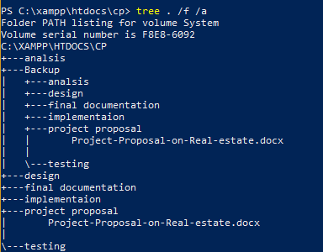

Figure configuration management.

# Chapter: 7 Conclusion:

Identifying that property buying selling and rental is difficult process in my area. I am trying to solve this problem by creating a website which will centralized property buying and selling online. Buyer/Seller doesn't have to deal with agents and frauds to buy/sell property. This website will also help for data collection of real estate valuation so everyone can identify value of property, which leads to happy customers. Project will be developed using waterfall methodology, which is a traditional process for software development. MVC design pattern will be used as a design framework for development of this project. Server/client architecture will be used as an architecture for development of this project. In server/client architecture, data will be uploaded in a different server which makes easier and faster for user to access information. Project planning will be done by using WBS structure and creating Gantt chart with milestone for proper planning against time. Risk management will be calculated using risk table for this project. Security will be kept as a major factor of this project as user must be allowed to uses secure website.

# Chapter 8: References

Synopsys. (2019). *Synopsys, Top 4 Software Development Methodologies |*. Retrieved from Software Integrity Blog: https://www.synopsys.com/blogs/software-security/top-4-software-development-methodologies/

Freelock.com. (2019). *10 Problems with Web Development Projects, and How We've Solved Them | Security, Insights, and Results for your Drupal or WordPress Website*. [online] Available at: https://www.freelock.com/newsletter/10-problems-web-development-projects-and-how-weve-solved-them [Accessed 2 Apr. 2019].

Tensix.com. (2019). [online] Available at: https://tensix.com/2015/08/the-value-of-milestones-in-project-scheduling/ [Accessed 9 Apr. 2019].

Hhs.gov. (2019). [online] Available at: https://www.hhs.gov/sites/default/files/ocr/privacy/hipaa/administrative/securityrule/nist800-30.pdf [Accessed 9 Apr. 2019].

Visual.ly. (2019). *Ecommerce Business Risk | Visual.ly*. [online] Available at: https://visual.ly/community/infographic/business/ecommerce-business-risk [Accessed 1 Apr. 2019].

GeeksforGeeks. (2019). *MVC Design Pattern - GeeksforGeeks*. [online] Available at: https://www.geeksforgeeks.org/mvc-design-pattern/ [Accessed 9 Apr. 2019].

Pmi-portland.org. (2019). *Risk Management Agile v Waterfall (Runcie)*. [online] Available at: https://pmi-portland.org/news-and-content/675-risk-management-agile-v-waterfall [Accessed 9 Apr. 2019].

Bright Hub PM. (2019). *What is a Work Breakdown Structure? Examples of a WBS*. [online] Available at: https://www.brighthubpm.com/templates-forms/2645-what-is-a-work-breakdown-structure/ [Accessed 9 Apr. 2019].

| (2019). *Client Server Architecture*. [online] Ecomputernotes.com. Available at: http://ecomputernotes.com/computernetworkingnotes/network-technologies/what-is-client-server-architecture [Accessed 9 Apr. 2019].

Webopedia.com. (2019). *What is Client Server Architecture? Webopedia Definition*. [online] Available at: https://www.webopedia.com/TERM/C/client_server_architecture.html [Accessed 9 Apr. 2019].

Smartdraw.com. (2019). *Gantt Chart - What is a Gantt Chart?*. [online] Available at: https://www.smartdraw.com/gantt-chart/ [Accessed 9 Apr. 2019].

Htmlgoodies.com. (2019). *Principles Of MVC for PHP Developers*. [online] Available at: https://www.htmlgoodies.com/beyond/php/article.php/3912211/Principles-Of-MVC-for-PHP-Developers.html [Accessed 9 Apr. 2019].

Gantt.com. (2019). *What is a Gantt Chart? Gantt Chart Software, Information, and History*. [online] Available at: https://www.gantt.com/ [Accessed 9 Apr. 2019].